RETAIL SALES DATABASE MANAGEMENT SYSTEM

Priyanka Kotha

Table of Contents

Overview 3

Objective and Scope 3

User requirements 4

Business rules 5

Entity relationship diagram 6

Data Dictionary 7

Database creation 8

Insert records in tables 13

SQL queries 22

# **Overview**

In this project, we are making an attempt to create a retail sales database management system to maintain the customer records, order details, product details, shipping details. New customer information can be inserted and updated. The management can track all the sale items and product details and can easily have an idea of what is the progress in their store. Additionally, they can also check the demand of the particular products and can make prior arrangements in getting those products with more stock. There are so many potential advantages out of which some of them are mentioned here. The main idea of this retail sales management system is to provide centralized data access and control and track the customer details effectively.

# **Objective and Scope**

For large stores or even small stores it is very difficult to search the customer records, order records or product records manually and it is time consuming. Retail Management is the process which helps the customers to procure the desired merchandise form the retail stores for their personal use. It includes all the steps required to bring the customers into the store and fulfill their buying needs.

A retail company’s data about how it serves its customers and/or how the customer is reacting to its service reflects the company’s role in nurturing its customer base. Historical data however is not only just an indicator of how bad or good the company is doing but can also give a very important insight about what can be done to maximize its profits depending on consumer behavior. Managing the database is extremely helpful in this scenario.

Furthermore, the Retail sales management system saves time and ensures the customers easily locate their desired merchandise and return home satisfied. All the orders and shipping details can be tracked.

Moreover, using this system, users may be able to add customer details, add dependents with customers, delete customers, update order, track product details etc.

This system will help to improve the performance. The management may be able to display different details and information regarding the retail sales very quickly and efficiently. List of customers and their orders that belong to specific city, country, region and market can be taken out within seconds. This current system will improve the growth of the store and helps keep themselves very organized.

# **User requirements**

Customers would be satisfied if they get their orders properly on time based on the priority and would be more than happy if they have overall good experiences with the shopping they do in stores. This project is an attempt to make it easier for the retail management to access the customer information, their product details, order details etc. Timely responses and delivering goods are really important as it helps the store business to nurture and take it to the next level.

Following are the main operations will be performed by retail sales database management system

Add customer

Add order details

Getting to know product details and sales information

Track shipment details

To know the priority of the order.

Search customer

Number of days taken to ship the order based on priority

To know the products with particular category and sub-category

For implementation of this system we need MYSQL as DBMS, Laptop Corei3 or Above.

Details about hardware and software used in project

a. Laptop Core i7- 3632QM CPU @2.20GHz, RAM 12.0GB

b. MAC 64 bit Operating system.

c. MySQL 8.0 DBMS

d. MySQL Workbench

e. Microsoft Visio 2016

f. Microsoft Word 2016

# **Business rules**

1. One Customer can place zero or many orders.
2. Several orders can be placed by a single customer.
3. Multiple ( one or many) products can be in a single order.
4. Each order can contain one or more products.
5. There can be one or many products in a single shipment.
6. One customer can have zero or many shipments.
7. Each customer can have one and only one location and one location is aligned with one customer.
8. One customer can have zero or many products as sale items.
9. Each product can be a zero or many sale items.
10. Every sale item can have one or many products.

# **Entity relationship diagram**

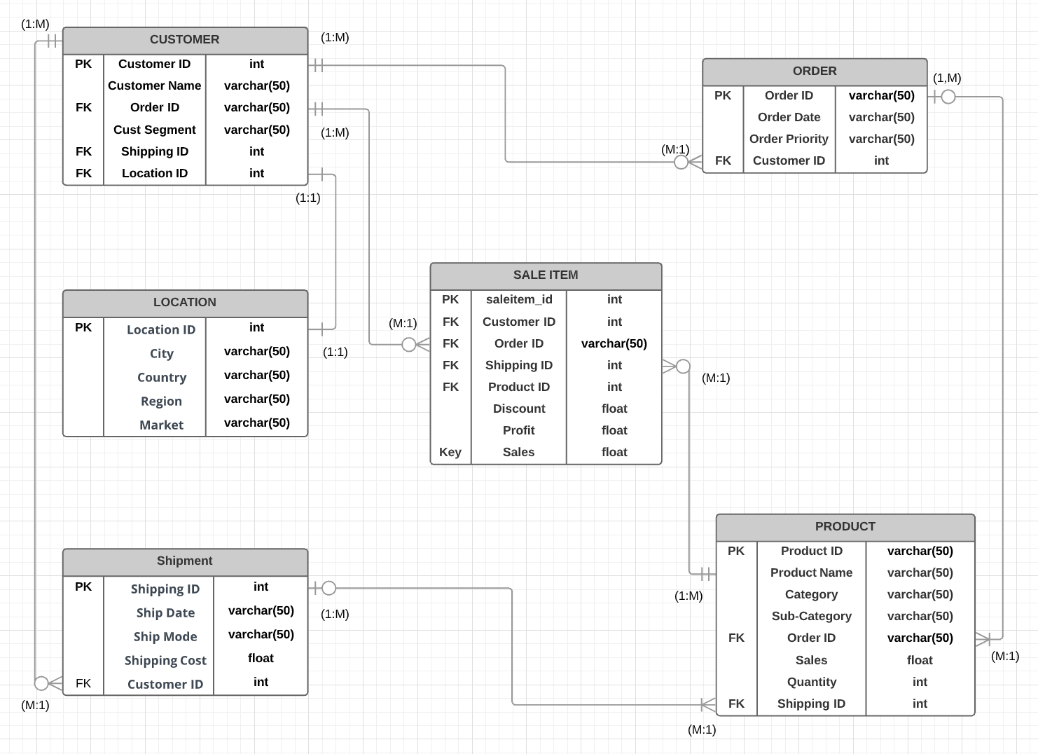

# **Data Dictionary**

|  |  |  |  |  |  |
| --- | --- | --- | --- | --- | --- |
| Table Name | Attributes | Datatype | Range | Constraint | Reference table |
| Customer | Customer ID  CustomerName  OrderID  CustSegment  ShippingID  LocationID | Int  Varchar(50)  Varchar(50)Varchar(50)  Int  Int | 00000-99999  00000-99999  00000-99999 | PK  FK  FK FK | Order  Location |
| Location | LocationID  City  Country  Region  Market | Int  Varchar (50)  Varchar (50)  Varchar (50)  Varchar (50) | 00000-99999 | PK |  |
| Order | OrderID  Order Date  Order Priority  Customer ID | Varchar (50))  Varchar (50)  Varchar (50)  Int | 00000-99999 | PK  FK | Customer |
| Product | Product ID  Product Name  Category  Sub-Category  OrderID  Sales  Quantity  ShippingID | Varchar (50)  Varchar (50)  Varchar (50)  Varchar (50)  Varchar (50)  Float  Int  Int | 00000-99999  00000-99999 | PK  FK  FK | Order |
| Shipment | ShippingID  Ship Date  Ship Mode  Shipping Cost  Customer ID | Int  Varchar (50)  Varchar (50)  Float  Int | 00000-99999  00000-99999  00000-99999 | PK  FK | Customer |
| Sale Item | Saleitem_id  Customer ID  OrderID  ShippingID  Product ID  Discount  Profit  Sales | Int  Int  Varchar (50)  Int  Int  Int  Int  Float | 00000-99999  00000-99999  00000-99999  00000-99999  00000-99999 | PK  FK  FK  FK  FK | Product  Customer |

# **Database creation**

CREATE DATABASE retail_sales;

The name of the database is retail_sales

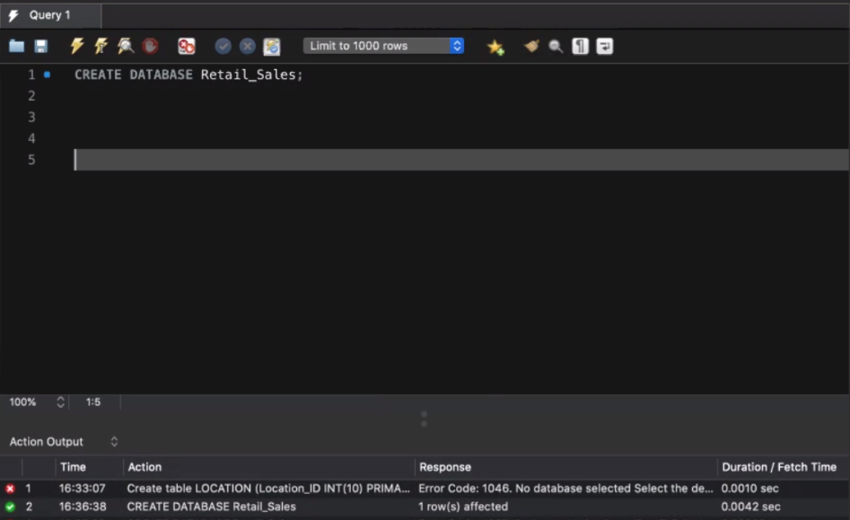

List of tables:

1. Customer table

/*customer table creation*/

CREATE TABLE `retail_sales`.`customer` (

`customer_id` INT NOT NULL,

`customer_name` VARCHAR(45) NOT NULL,

`customer_segment` VARCHAR(45) NOT NULL,

`shipping_id` INT NOT NULL,

`order_id` VARCHAR(45) NOT NULL,

foreign key (order_id) REFERENCES order(order_id) on update cascade,

`location_id` INT NOT NULL,

foreign key (location_id) REFERENCES location(location_id) on update cascade,

PRIMARY KEY (`customer_id`));

1. Location table

/*Location table*/

CREATE TABLE `retail_sales`.`location` (

`location_id` INT NOT NULL,

`city` VARCHAR(45) NULL,

`country` VARCHAR(45) NULL,

`region` VARCHAR(45) NULL,

`market` VARCHAR(45) NULL,

PRIMARY KEY (`location_id`));

1. Saleitem table

/*Saleitem table*/

CREATE TABLE `retail_sales`.`sale_item` (

`saleitem_id` INT NOT NULL,

`sales` VARCHAR (45) NOT NULL,

`customer_id` VARCHAR(45) NOT NULL,

foreign key (customer_id) REFERENCES customer(customer_id) on update cascade,

`order_id` VARCHAR(45) NOT NULL,

foreign key (order_id) REFERENCES order(order_id) on update cascade,

`shipping_id` INT NOT NULL,

foreign key (shipping_id) REFERENCES shipment(shipping_id) on update cascade,

`product_id` VARCHAR(45) NOT NULL,

foreign key (product_id) REFERENCES product(product_id) on update cascade,

`discount` INT NULL,

`profit` VARCHAR(45) NOT NULL,

PRIMARY KEY (`saleitem_id`));

1. Order table

/*Order table*/

CREATE TABLE `retail_sales`.`order` (

`order_id` VARCHAR(45) NOT NULL,

`order_date` VARCHAR(45) NULL,

`order_priority` VARCHAR(45) NULL,

`customer_id` VARCHAR(45) NULL,

foreign key (customer_id) REFERENCES customer(customer_id) on update cascade,

PRIMARY KEY (`order_id`));

1. Shipment table

/*Shipment table*/

CREATE TABLE `retail_sales`.`shipment` (

`shipping_id` INT NOT NULL,

`shipping_date` VARCHAR(45) NOT NULL,

`shipping_mode` VARCHAR(45) NOT NULL,

`shipping_cost` VARCHAR(45) NOT NULL,

`customer_id` VARCHAR(45) NOT NULL,

foreign key (customer_id) REFERENCES customer(customer_id) on update cascade,

PRIMARY KEY (`shipping_id`));

1. Product table

/*product table*/

CREATE TABLE `retail_sales`.`product` (

`product_id` VARCHAR(45) NOT NULL,

`product_name` VARCHAR(45) NOT NULL,

`prod_category` VARCHAR(45) NOT NULL,

`prod_subcategory` VARCHAR(45) NOT NULL,

`order_id` VARCHAR(45) NOT NULL,

foreign key (order_id) REFERENCES order(order_id) on update cascade,

`sales` VARCHAR(45) NOT NULL,

`quantity` VARCHAR(45) NULL,

`shipping_id` INT NOT NULL,

foreign key (shipping_id) REFERENCES shipping(shipping_id) on update cascade,

PRIMARY KEY (`product_id`));

List of tables in database:

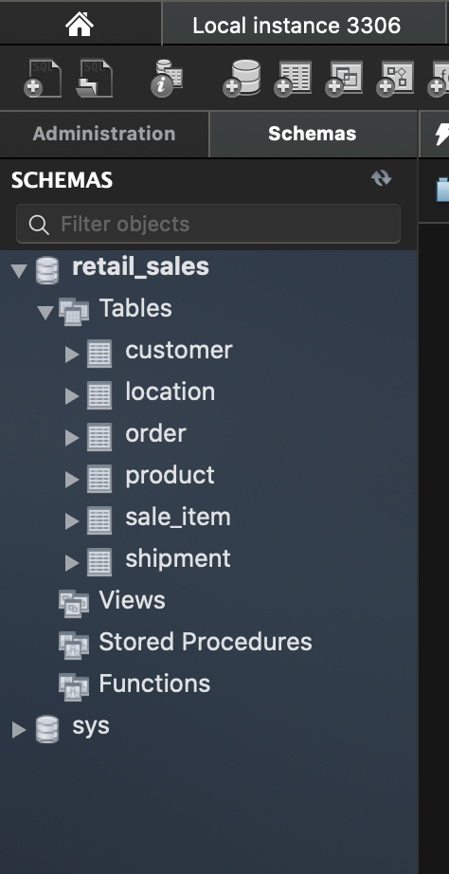

# **Insert records in tables**

Table – 1 /*Inserting values into customer table*/

Customer table

CUSTOMER TABLE

INSERT INTO `retail sales`. `customer` (`customer_id`, `customer_name`, `customer_segment`, `order_id`, `shipping_id`, `location_id`) VALUES ('CA-120551', 'Cathy Armstrong', 'Home Office', 'IN-2017-CA120551-42816', '24599', '101');

INSERT INTO `retail sales`. `customer` (`customer_id`, `customer_name`, `customer_segment`, `order_id`, `shipping_id`, `location_id`) VALUES ('BD-116051', 'Brian Dahlen', 'Consumer', 'ID-2015-BD116051-42248', '29465', '102');

INSERT INTO `retail_sales`.`customer` (`customer_id`, `customer_name`, `customer_segment`, `order_id`, `shipping_id`, `location_id`) VALUES ('TS-213401', 'Toby Swindell', 'Consumer', 'IN-2017-TS213401-43092', '24892', '103');

INSERT INTO `retail_sales`.`customer` (`customer_id`, `customer_name`, `customer_segment`, `order_id`, `shipping_id`, `location_id`) VALUES ('DW-131951', 'David Wiener', 'Corporate', 'IN-2015-DW131951-42160', '29585', '104');

INSERT INTO `retail sales`. `customer` (`customer_id`, `customer_name`, `customer_segment`, `order_id`, `shipping_id`, `location_id`) VALUES ('JG-151151', 'Jack Garza', 'Consumer', 'IN-2017-JG151151-43032', '20728', '105');

INSERT INTO `retail_sales`.`customer` (`customer_id`, `customer_name`, `customer_segment`, `order_id`, `shipping_id`, `location_id`) VALUES ('AJ-107801', 'Anthony Jacobs', 'Corporate', 'ID-2015-AJ107801-42113', '28879', '106');

INSERT INTO `retail_sales`.`customer` (`customer_id`, `customer_name`, `customer_segment`, `order_id`, `shipping_id`, `location_id`) VALUES ('GM-144551', 'Gary Mitchum', 'Home Office', 'IN-2017-GM144551-42948', '27993', '107');

INSERT INTO `retail_sales`.`customer` (`customer_id`, `customer_name`, `customer_segment`, `order_id`, `shipping_id`, `location_id`) VALUES ('VB-217451', 'Victoria Brennan', 'Corporate', 'IN-2017-VB217451-43080', '28967', '108');

INSERT INTO `retail_sales`.`customer` (`customer_id`, `customer_name`, `customer_segment`, `order_id`, `shipping_id`, `location_id`) VALUES ('LO-171701', 'Lori Olson', 'Corporate', 'IN-2016-LO171701-42637', '29492', '109');

INSERT INTO `retail_sales`.`customer` (`customer_id`, `customer_name`, `customer_segment`, `order_id`, `shipping_id`, `location_id`) VALUES ('RS-194201', 'Ricardo Sperren', 'Corporate', 'IN-2014-RS 194201-41867', '23951', '110');

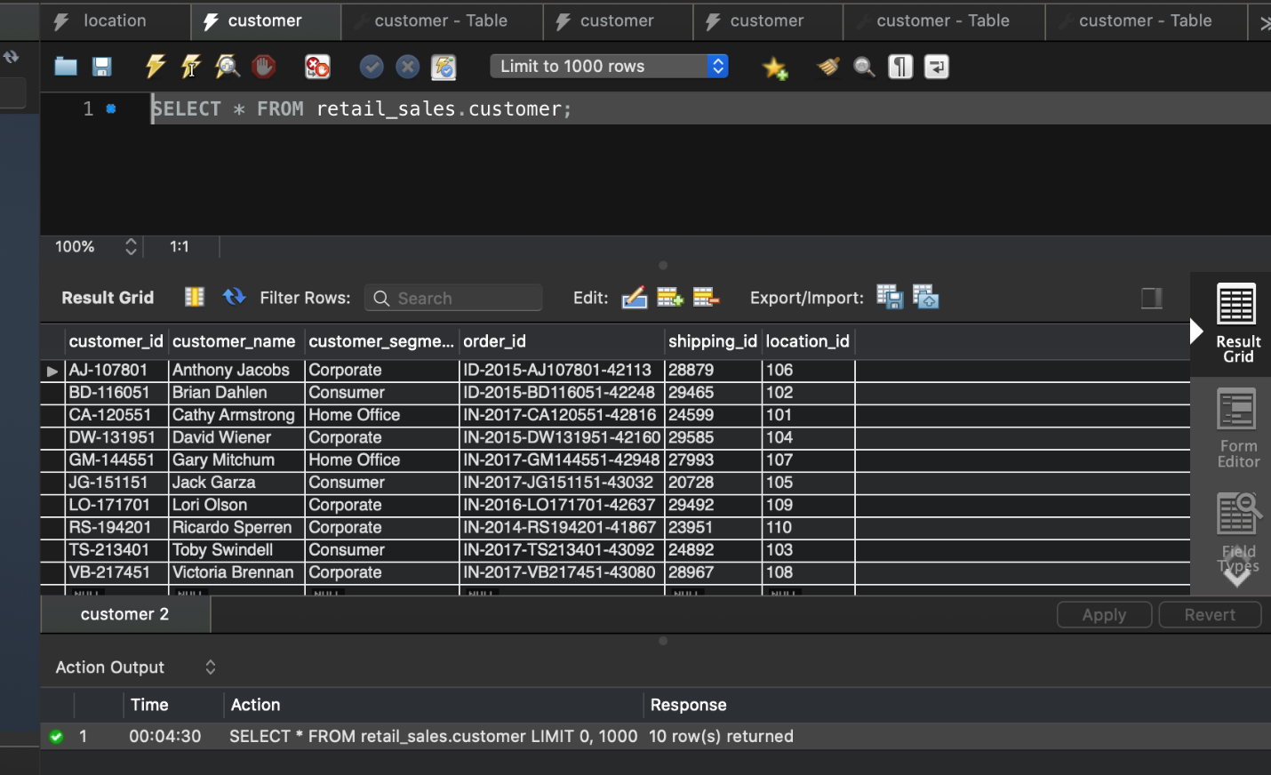

Table -2 /*Inserting values into location table*/

Location table

Columns : location_id, city, country, region, market

LOCATION TABLE

INSERT INTO `retail_sales`. `location` (`location_id`, `city`, `country`, `region`, `market`) VALUES ('101', 'Mumbai', 'India', 'Western Asia', 'Western Pacific');

INSERT INTO `retail_sales`.`location` (`location_id`, `city`, `country`, `region`, `market`) VALUES ('102', 'Herat', 'Afghanistan', 'Southern Asia', 'Asia Pacific');

INSERT INTO `retail_sales`.`location` (`location_id`, `city`, `country`, `region`, `market`) VALUES ('103', 'Heart', 'Afghanistan', 'Southern Asia', 'Asia Pacific');

INSERT INTO `retail_sales`.`location` (`location_id`, `city`, `country`, `region`, `market`) VALUES ('104', 'Mumbai', 'India', 'Western Asia', 'West Pacific');

INSERT INTO `retail_sales`.`location` (`location_id`, `city`, `country`, `region`, `market`) VALUES ('105', 'Heart', 'Afghanistan', 'Southern Asia', 'Asia Pacific');

INSERT INTO `retail_sales`.`location` (`location_id`, `city`, `country`, `region`, `market`) VALUES ('106', 'London', 'United Kingdom', 'Europe', 'East Atlantic');

INSERT INTO `retail_sales`.`location` (`location_id`, `city`, `country`, `region`, `market`) VALUES ('107', 'Kabul', 'Afghanistan', 'Southern Asia', 'Asia Pacific');

INSERT INTO `retail_sales`.`location` (`location_id`, `city`, `country`, `region`, `market`) VALUES ('108', 'NewYork', 'United States', 'Northern America', 'West Atlantic');

INSERT INTO `retail_sales`.`location` (`location_id`, `city`, `country`, `region`, `market`) VALUES ('109', 'NewYork', 'United States', 'Northern America', 'West Atlantic');

INSERT INTO `retail_sales`.`location` (`location_id`, `city`, `country`, `region`, `market`) VALUES ('110', 'Kabul', 'Afghanistan', 'Southern Asia', 'Asia Pacific');

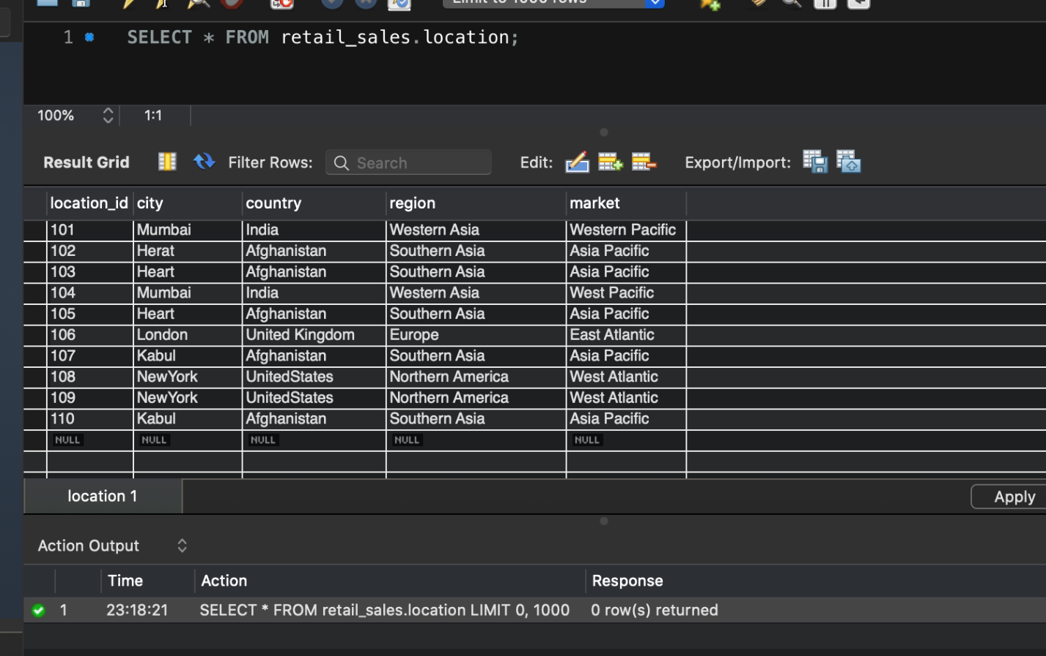

Table-3 - /*Inserting values into order table*/

Order table

Columns : order_id, order_date, order_priority, customer_id

ORDER TABLE

INSERT INTO `retail_sales`.`order` (`order_id`, `order_date`, `order_priority`, `customer_id`) VALUES ('ID-2015-AJ107801-42113', '4/19/2015', 'High', 'AJ-107801');

INSERT INTO `retail_sales`.`order` (`order_id`, `order_date`, `order_priority`, `customer_id`) VALUES ('ID-2015-BD116051-42248', '9/1/2015', 'Medium', 'BD-116051');

INSERT INTO `retail_sales`.`order` (`order_id`, `order_date`, `order_priority`, `customer_id`) VALUES ('ID-2015-SS201401-42354', '12/16/2015', 'Medium', 'SS-201401');

INSERT INTO `retail_sales`.`order` (`order_id`, `order_date`, `order_priority`, `customer_id`) VALUES ('IN-2014-RS 194201-41867', '8/18/2014', 'Critical', 'RS-194201');

INSERT INTO `retail_sales`.`order` (`order_id`, `order_date`, `order_priority`, `customer_id`) VALUES ('IN-2015-BG110351-42275', '9/28/2015', 'Low', 'BG-110351');

INSERT INTO `retail_sales`.`order` (`order_id`, `order_date`, `order_priority`, `customer_id`) VALUES ('IN-2015-DW131951-42160', '6/10/2015', 'Medium', 'DW-131951');

INSERT INTO `retail_sales`.`order` (`order_id`, `order_date`, `order_priority`, `customer_id`) VALUES ('IN-2016-AH105851-42701', '11/27/2016', 'High', 'AH-105851');

INSERT INTO `retail_sales`.`order` (`order_id`, `order_date`, `order_priority`, `customer_id`) VALUES ('IN-2016-CS118451-42387', '1/18/2016', 'High', 'CS-118451');

INSERT INTO `retail_sales`.`order` (`order_id`, `order_date`, `order_priority`, `customer_id`) VALUES ('IN-2016-LO171701-42637', '9/24/2016', 'Medium', ' LO-171701');

INSERT INTO `retail_sales`.`order` (`order_id`, `order_date`, `order_priority`, `customer_id`) VALUES ('IN-2017-AA103751-42926', '7/10/2017', 'High', 'AA-103751');

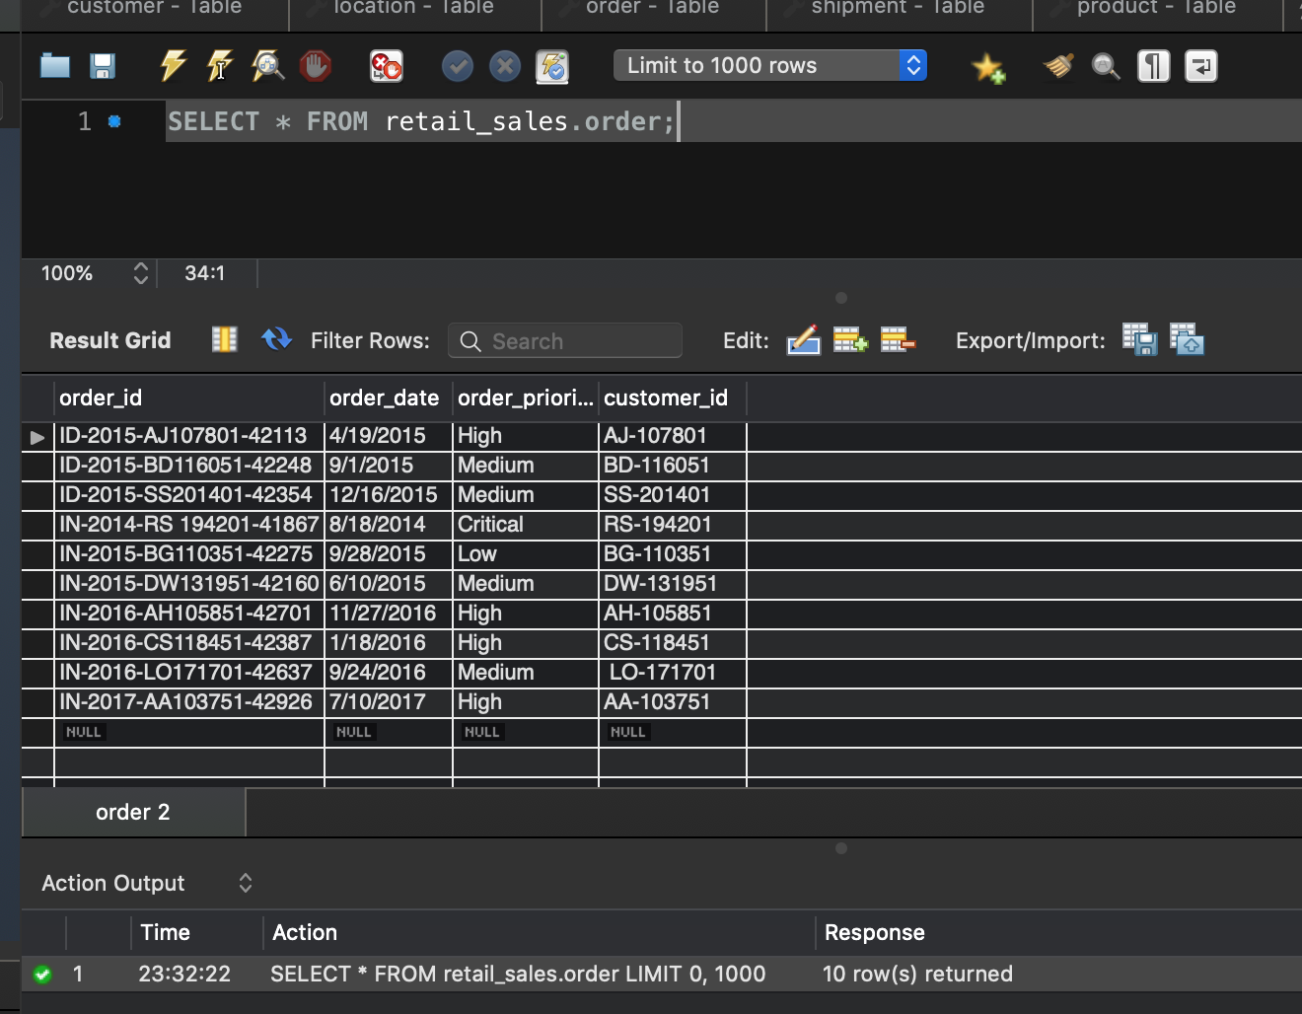

|  |
| --- |
|  |

Table -4 /*Inserting values into product table*/

Product table

Columns: product_id, product_name, prod_category, prod_subcategory, sales, quantity, order_id, shipping_id

PRODUCT TABLE:

INSERT INTO `retail_sales`.`product` (`product_id`, `product_name`, `prod_category`, `prod_subcategory`, `order_id`, `sales`, `quantity`, `shipping_id`) VALUES ('FUR-BO-3626', 'Bush Classic Bookcase, Pine', 'Furniture', 'Bookcases', 'IN-2017-GM144551-42948', '2070', '5', '27993');

INSERT INTO `retail_sales`.`product` (`product_id`, `product_name`, `prod_category`, `prod_subcategory`, `order_id`, `sales`, `quantity`, `shipping_id`) VALUES ('FUR-BO-4861', 'Ikea Library with Doors,Mobile,', 'Furniture', 'Bookcases', 'IN-2017-CA120551-42816', '732', '2', '24599');

INSERT INTO `retail_sales`.`product` (`product_id`, `product_name`, `prod_category`, `prod_subcategory`, `order_id`, `sales`, `quantity`, `shipping_id`) VALUES ('FUR-CH-4523', 'Harbour Creations Chairmat, Black', 'Furniture', 'Chairs', 'IN-2016-AH105851-42701', '417', '6', '28265');

INSERT INTO `retail_sales`.`product` (`product_id`, `product_name`, `prod_category`, `prod_subcategory`, `order_id`, `sales`, `quantity`, `shipping_id`) VALUES ('FUR-CH-4683', 'Hon Rocking Chair, Red', 'Furniture', 'Chairs', 'IN-2017-VB217451-43080', '914', '7', '28967');

INSERT INTO `retail_sales`.`product` (`product_id`, `product_name`, `prod_category`, `prod_subcategory`, `order_id`, `sales`, `quantity`, `shipping_id`) VALUES ('FUR-TA-3420', 'Bevis Conference Table, Fully Assembled', 'Furniture', 'Tables', 'ID-2015-AJ107801-42113', '4626', '5', '28879');

INSERT INTO `retail_sales`.`product` (`product_id`, `product_name`, `prod_category`, `prod_subcategory`, `order_id`, `sales`, `quantity`, `shipping_id`) VALUES ('FUR-TA-3780', 'Chromcraft Wood Table, with Bottom Storage', 'Furniture', 'Tables', 'ID-2015-SS201401-42354', '1448', '3', '25232');

INSERT INTO `retail_sales`.`product` (`product_id`, `product_name`, `prod_category`, `prod_subcategory`, `order_id`, `sales`, `quantity`, `shipping_id`) VALUES ('OFF-AP-4747', 'Hoover Toaster, Red', 'Office Supplies', 'Appliances', 'IN-2017-AA103751-42926', '669', '8', '23222');

INSERT INTO `retail_sales`.`product` (`product_id`, `product_name`, `prod_category`, `prod_subcategory`, `order_id`, `sales`, `quantity`, `shipping_id`) VALUES ('OFF-AR-3457', 'BIC Markers, Easy-Erase', 'Office Supplies', 'Art', 'IN-2017-JG151151-43032', '160', '6', '20728');

INSERT INTO `retail_sales`.`product` (`product_id`, `product_name`, `prod_category`, `prod_subcategory`, `order_id`, `sales`, `quantity`, `shipping_id`) VALUES ('OFF-PA-5890', 'SanDisk Parchment Paper, 8.5 x 11', 'Office Supplies', 'Paper', 'IN-2014-RS 194201-41867', '83', '4', '23951');

INSERT INTO `retail_sales`.`product` (`product_id`, `product_name`, `prod_category`, `prod_subcategory`, `order_id`, `sales`, `quantity`, `shipping_id`) VALUES ('OFF-ST-6068', 'Smead Trays, Wire Frame', 'Office Supplies', 'Storage', 'IN-2016-CS118451-42387', '333', '7', '27278');

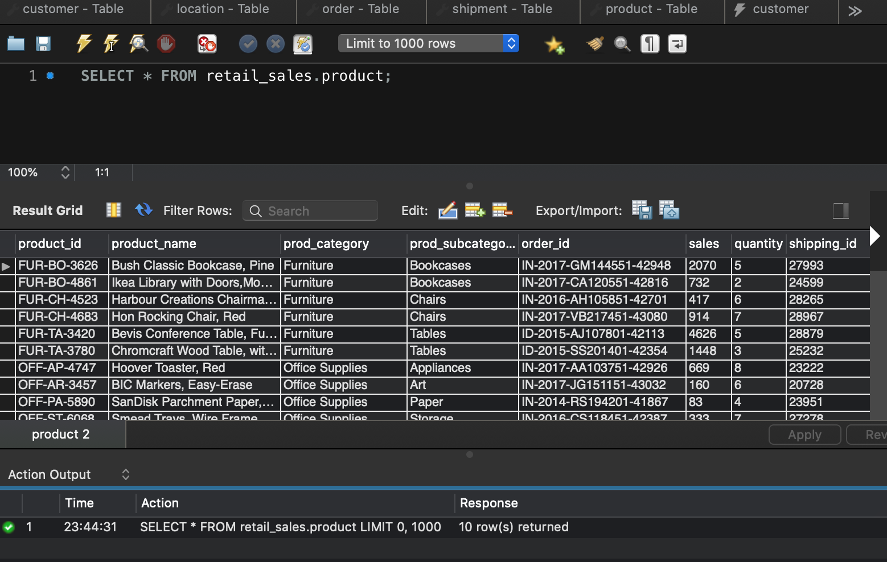

Table – 5 /*Inserting values into shipment table*/

Shipment table

INSERT INTO `retail_sales`.`shipment` (`shipping_id`, `shipping_date`, `shipping_mode`, `shipping_cost`, `customer_id`) VALUES ('20728', '10/27/2017', 'First Class', '18.2', 'JG-151151');

INSERT INTO `retail_sales`.`shipment` (`shipping_id`, `shipping_date`, `shipping_mode`, `shipping_cost`, `customer_id`) VALUES ('23222', '7/15/2017', 'Second Class', '73', 'AA-103751');

INSERT INTO `retail_sales`.`shipment` (`shipping_id`, `shipping_date`, `shipping_mode`, `shipping_cost`, `customer_id`) VALUES ('23951', '8/18/2014', 'First Class', '21', 'RS-194201');

INSERT INTO `retail_sales`.`shipment` (`shipping_id`, `shipping_date`, `shipping_mode`, `shipping_cost`, `customer_id`) VALUES ('24599', '3/29/2017', 'Standard Class', '40', 'CA-120551');

INSERT INTO `retail_sales`.`shipment` (`shipping_id`, `shipping_date`, `shipping_mode`, `shipping_cost`, `customer_id`) VALUES ('24892', '12/28/2017', 'Standard Class', '21', 'TS-213401');

INSERT INTO `retail_sales`.`shipment` (`shipping_id`, `shipping_date`, `shipping_mode`, `shipping_cost`, `customer_id`) VALUES ('25232', '12/20/2015', 'Standard Class', '74', 'SS-201401');

INSERT INTO `retail_sales`.`shipment` (`shipping_id`, `shipping_date`, `shipping_mode`, `shipping_cost`, `customer_id`) VALUES ('27278', '1/20/2016', 'First Class', '53', 'CS-118451');

INSERT INTO `retail_sales`.`shipment` (`shipping_id`, `shipping_date`, `shipping_mode`, `shipping_cost`, `customer_id`) VALUES ('27993', '8/5/2017', 'Standard Class', '185', 'GM-144551');

INSERT INTO `retail_sales`.`shipment` (`shipping_id`, `shipping_date`, `shipping_mode`, `shipping_cost`, `customer_id`) VALUES ('28265', '12/1/2016', 'Standard Class', '58', 'AH-105851');

INSERT INTO `retail_sales`.`shipment` (`shipping_id`, `shipping_date`, `shipping_mode`, `shipping_cost`, `customer_id`) VALUES ('28879', '4/22/2015', 'First Class', '836', 'AJ-107801');

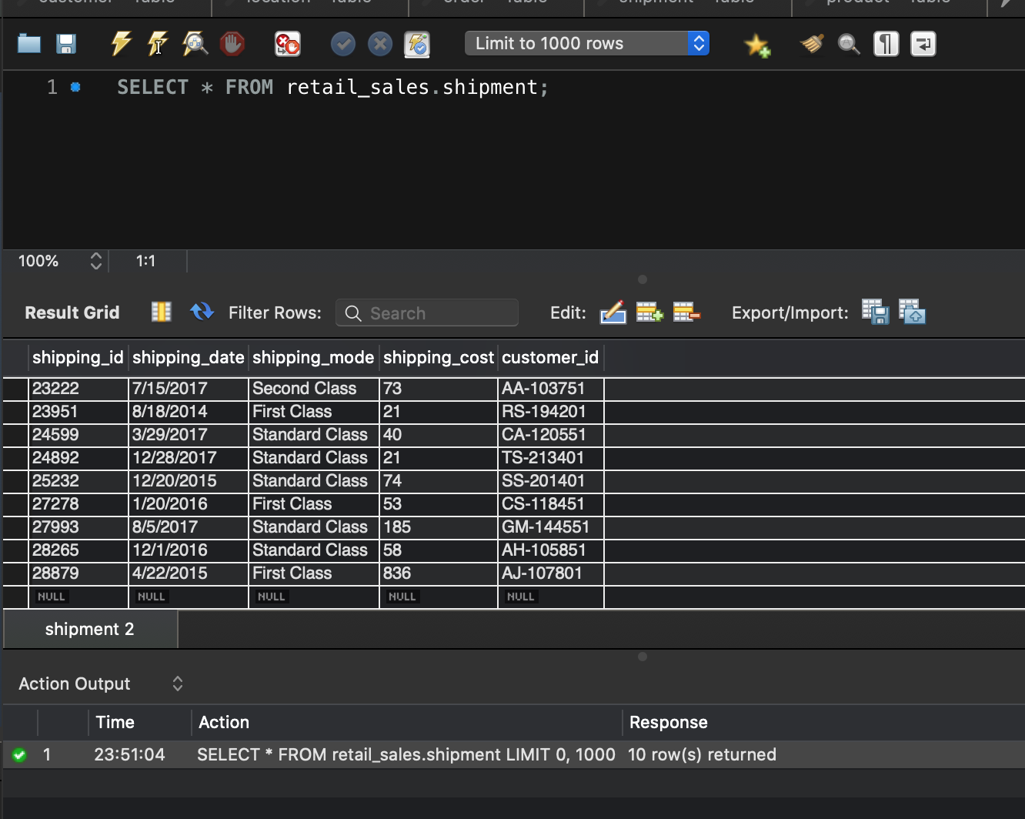

Table -6 /*Insert values into sale_item table*/

INSERT INTO `retail_sales`.`sale_item` (`saleitem_id`, `sales`, `customer_id`, `order_id`, `shipping_id`, `product_id`, `discount`, `profit`) VALUES ('121', '731.82', 'CA-120551', 'IN-2017-CA120551-42816', '24599', 'FUR-BO-4861', '0', '102.42');

INSERT INTO `retail_sales`.`sale_item` (`saleitem_id`, `sales`, `customer_id`, `order_id`, `shipping_id`, `product_id`, `discount`, `profit`) VALUES ('122', '243.54', 'BD-116051', 'ID-2015-BD116051-42248', '29465', 'OFF-SU-2988', '0', '104.49');

INSERT INTO `retail_sales`.`sale_item` (`saleitem_id`, `sales`, `customer_id`, `order_id`, `shipping_id`, `product_id`, `discount`, `profit`) VALUES ('123', '162.54', 'TS-21340', 'IN-2017-TS213401-43092', '24892', 'TEC-AC-4156', '0', '17.82');

INSERT INTO `retail_sales`.`sale_item` (`saleitem_id`, `sales`, `customer_id`, `order_id`, `shipping_id`, `product_id`, `discount`, `profit`) VALUES ('124', '848.4', 'DW-131951', 'IN-2015-DW131951-42160', '29585', 'TEC-PH-5812', '0', '364.8');

INSERT INTO `retail_sales`.`sale_item` (`saleitem_id`, `sales`, `customer_id`, `order_id`, `shipping_id`, `product_id`, `discount`, `profit`) VALUES ('125', '160.2', 'JG-151151', 'IN-2017-JG151151-43032', '20728', 'OFF-AR-3457', '0', '35.1');

INSERT INTO `retail_sales`.`sale_item` (`saleitem_id`, `sales`, `customer_id`, `order_id`, `shipping_id`, `product_id`, `discount`, `profit`) VALUES ('126', '4626.15', 'AJ-107801', 'ID-2015-AJ107801-42113', '28879', 'FUR-TA-3420', '0', '647.55');

INSERT INTO `retail_sales`.`sale_item` (`saleitem_id`, `sales`, `customer_id`, `order_id`, `shipping_id`, `product_id`, `discount`, `profit`) VALUES ('127', '2070.15', 'GM-14455', 'IN-2017-GM144551-4294', '27993', 'FUR-BO-3626', '0', '848.7');

INSERT INTO `retail_sales`.`sale_item` (`saleitem_id`, `sales`, `customer_id`, `order_id`, `shipping_id`, `product_id`, `discount`, `profit`) VALUES ('128', '914.34', 'VB-217451', 'IN-2017-VB217451-43080', '28967', 'FUR-CH-4683', '0', '356.58');

INSERT INTO `retail_sales`.`sale_item` (`saleitem_id`, `sales`, `customer_id`, `order_id`, `shipping_id`, `product_id`, `discount`, `profit`) VALUES ('129', '1168.44', 'LO-171701', 'IN-2016-LO171701-42637', '29492', 'TEC-PH-5814', '0', '443.94');

INSERT INTO `retail_sales`.`sale_item` (`saleitem_id`, `sales`, `customer_id`, `order_id`, `shipping_id`, `product_id`, `discount`, `profit`) VALUES ('130', '83.4', 'RS-194201', 'IN-2014-RS 194201-41867', '23951', 'OFF-PA-5890', '0', '8.28');

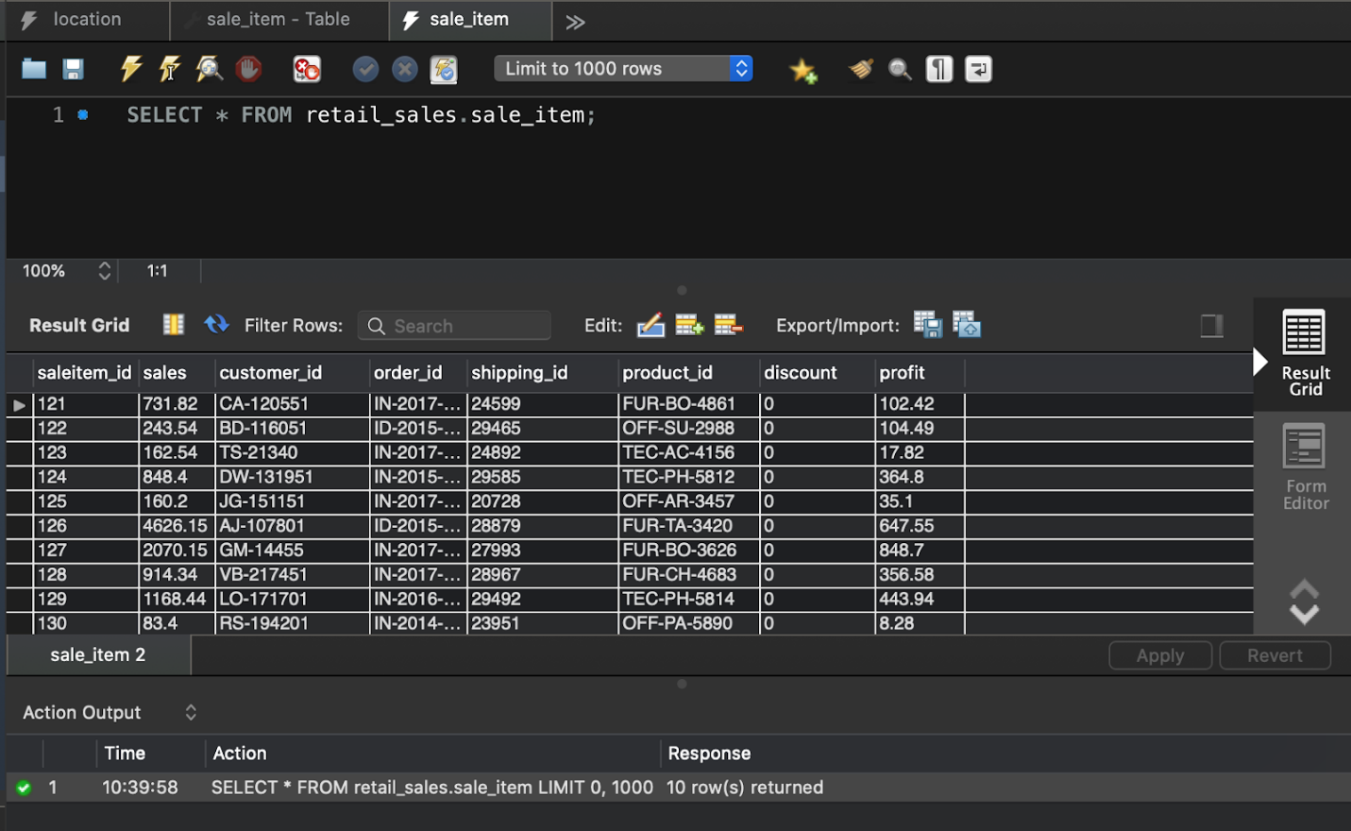

# **SQL queries**

Query- 1Basic information to know the customer details with respect to their cities

Getting to know the customer name, customer ID and their corresponding location id that belongs to the city ‘Herat’

SELECT c.customer_id, c.customer_name, l.location_id

FROM retail_sales.customer c join retail_sales.location l on c.location_id = l.location_id

WHERE l.city = 'Herat'

Similarly, we can know various other customers from different cities by changing the city name

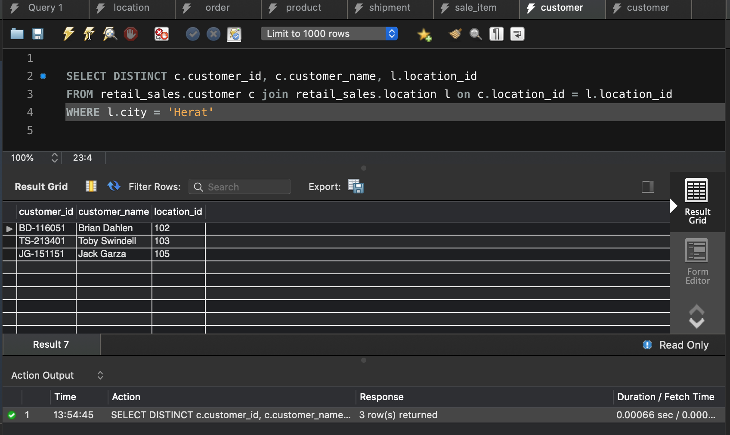

From the above query, we will get to know the basic information of getting to know the customer id and customer name with respect to their location. Similarly, we can also know the details of customer corresponding to various cities available in dataset.

Query – 2 Display the product category of Sales > 1000

SELECT prod_category, sales

FROM retail_sales.product

WHERE sales > 1000;

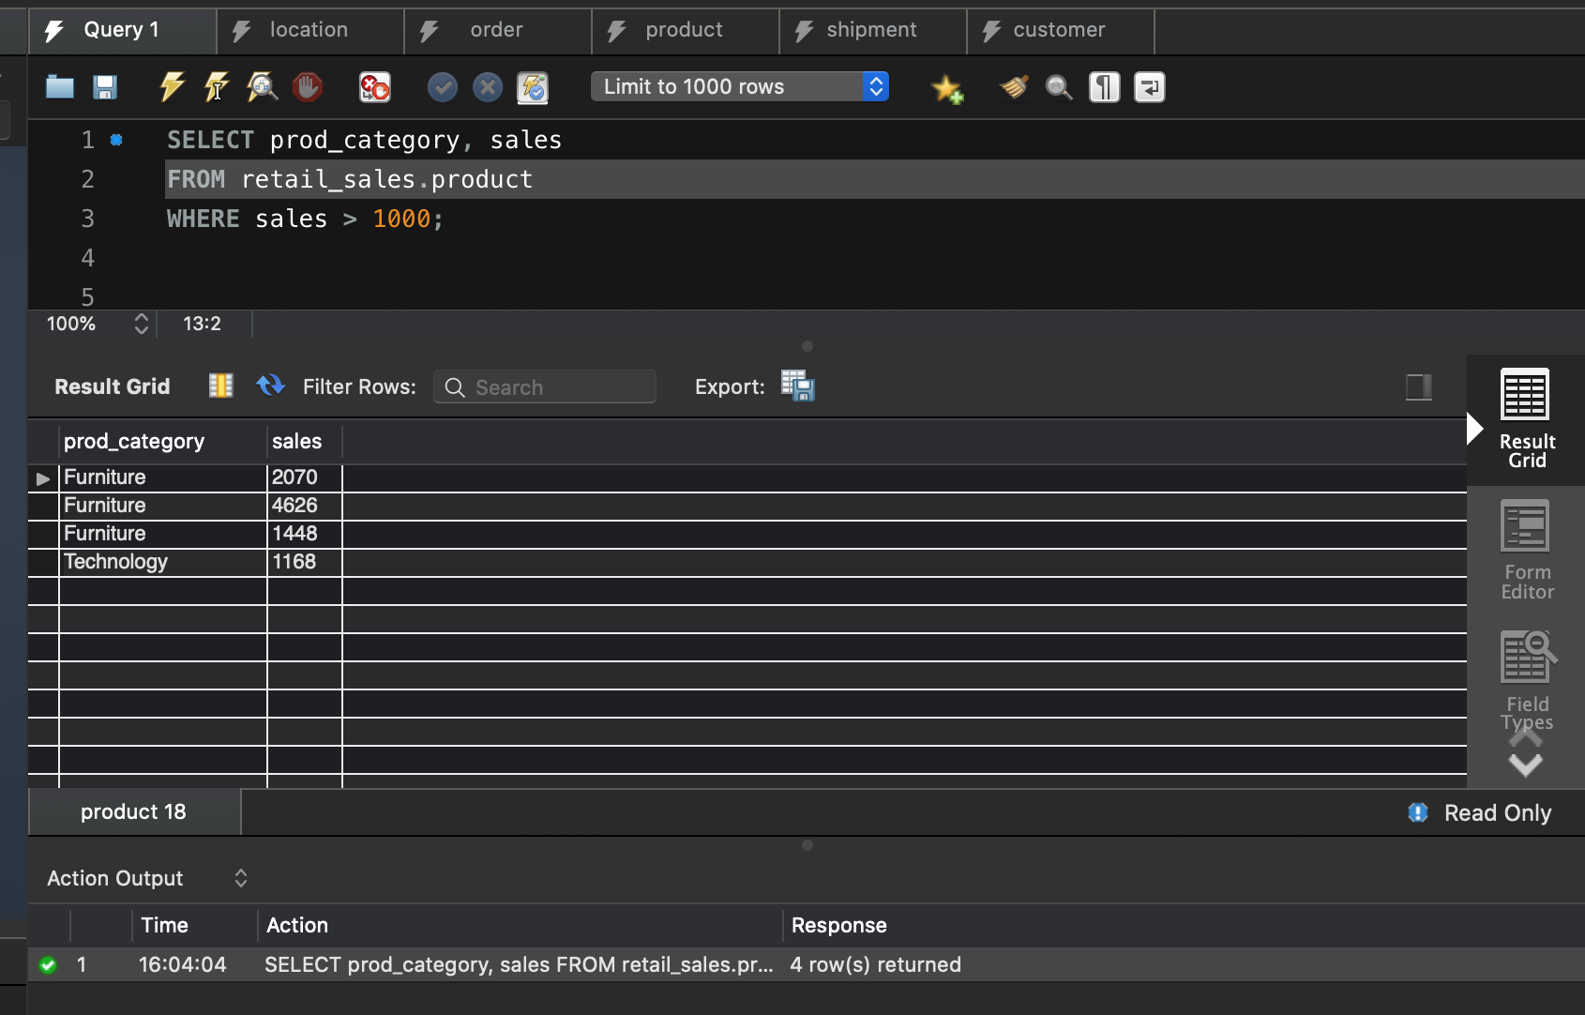

From the above query, we will know the product category having sales which are greater than 1000

Query -3. Getting to know the customers whose order priority is critical or high so that we can fulfill their orders immediately.

SELECT c.customer_id, c.customer_name, o.order_priority

FROM retail_sales.customer c join retail_sales.order o on c.customer_id = o.customer_id

WHERE o.order_priority = 'Critical' OR o.order_priority = 'High';

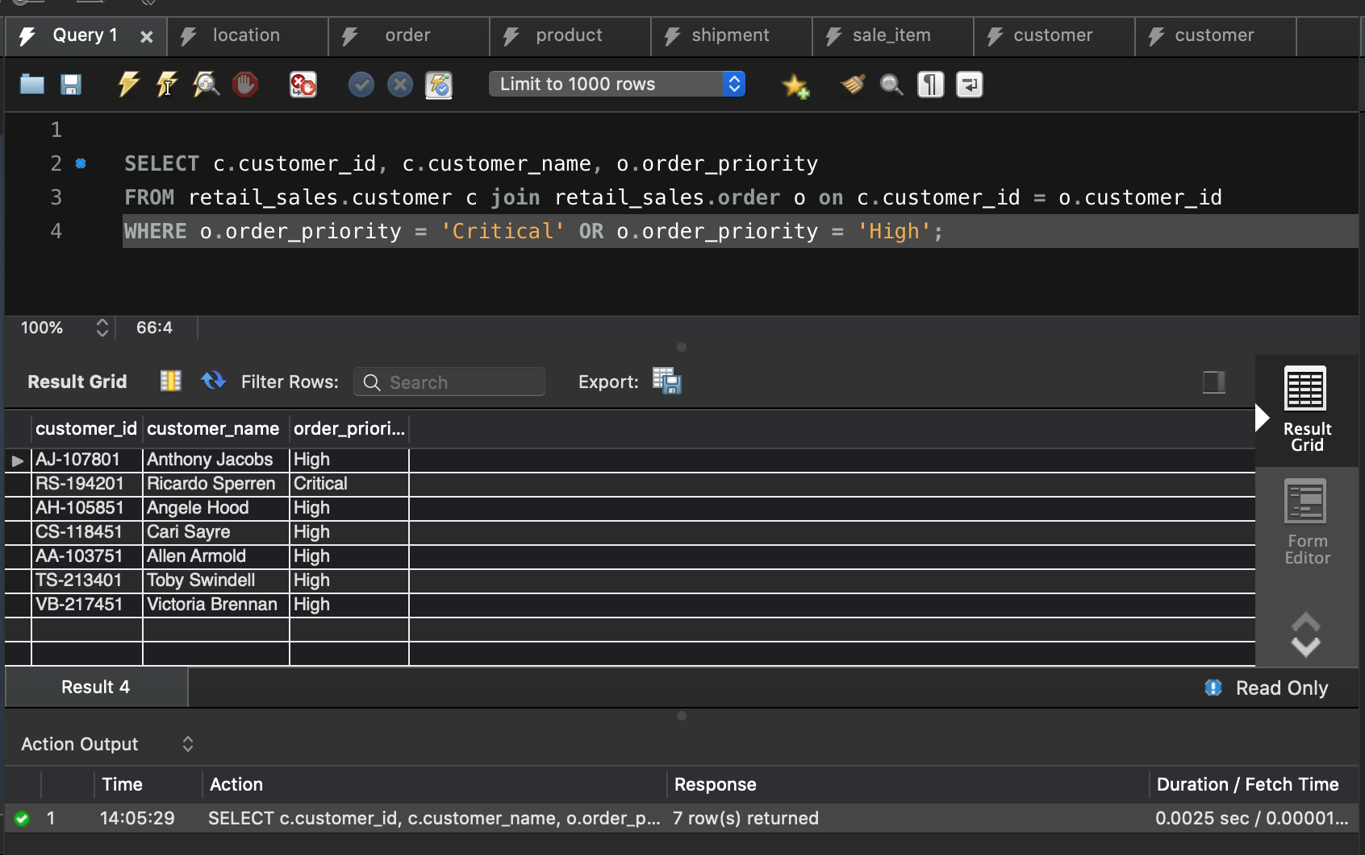

From the above query, we will know the customer details like customer id and customer name who has the highest order priority so that we can arrange and deliver the product as soon as possible may be in one day delivery.

Query - 4. Information based on particular category

SELECT DISTINCT c.customer_id, c.customer_name, p.prod_category

FROM retail_sales.customer c JOIN retail_sales.order o ON c.order_id = o.order_id

JOIN retail_sales.product p ON o.order_id = p.order_id

WHERE p.prod_category = 'Technology'

ORDER BY c.customer_name;

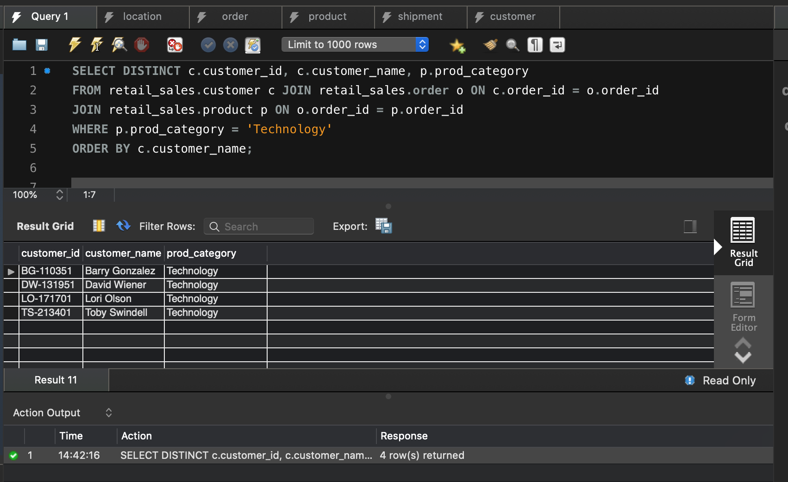

From the above query, we will get information of the customer id and customer name of particular product category.

Query - 5. Product name and its Shipping cost - which product has the highest shipping cost

SELECT p.product_name, s.shipping_cost

FROM retail_sales.product p JOIN retail_sales.shipment s ON p.shipping_id = s.shipping_id

ORDER BY s.shipping_cost;

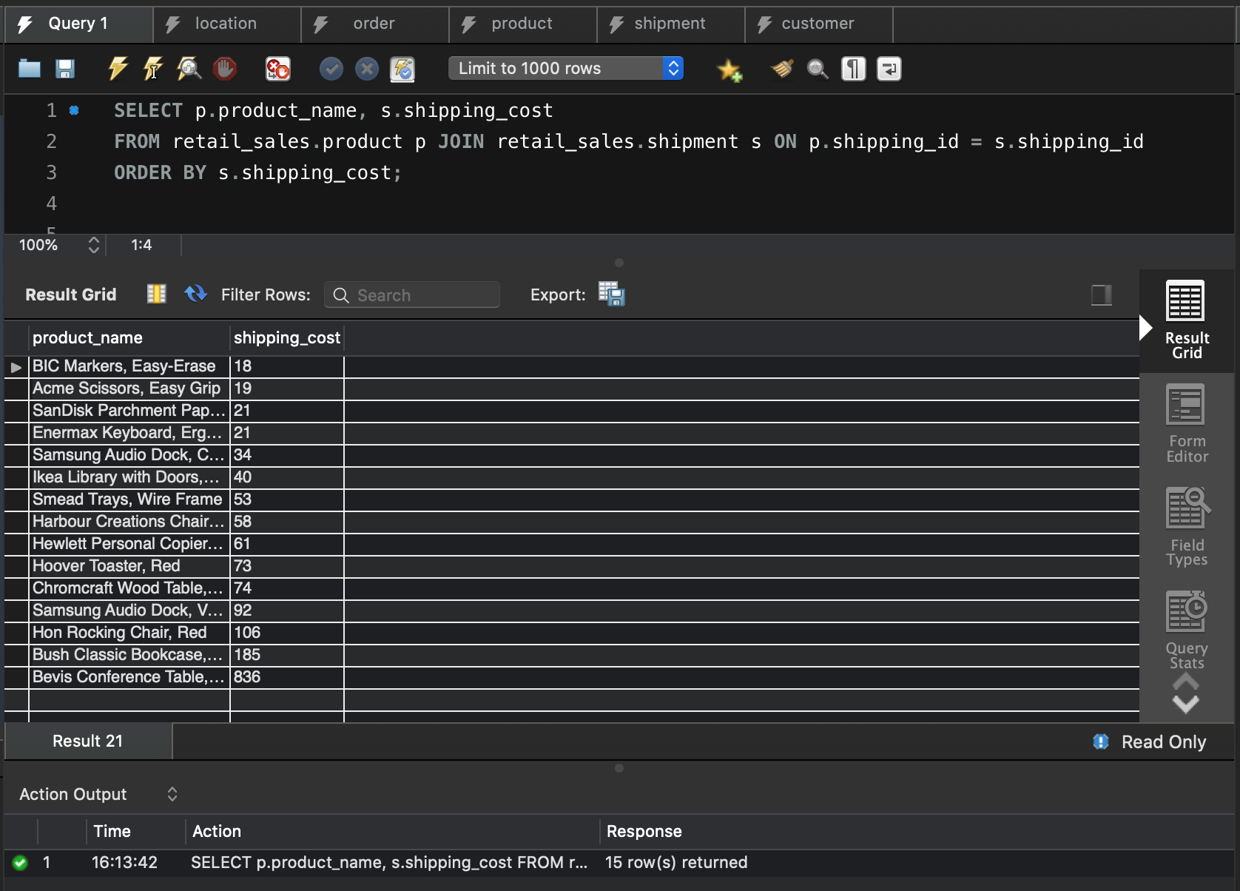

From the above query, we will know the information of the product with highest shipping cost.

Query - 6. Product demand and No. of products ordered

SELECT product_name, prod_category, quantity

FROM retail_sales.product

ORDER BY quantity;

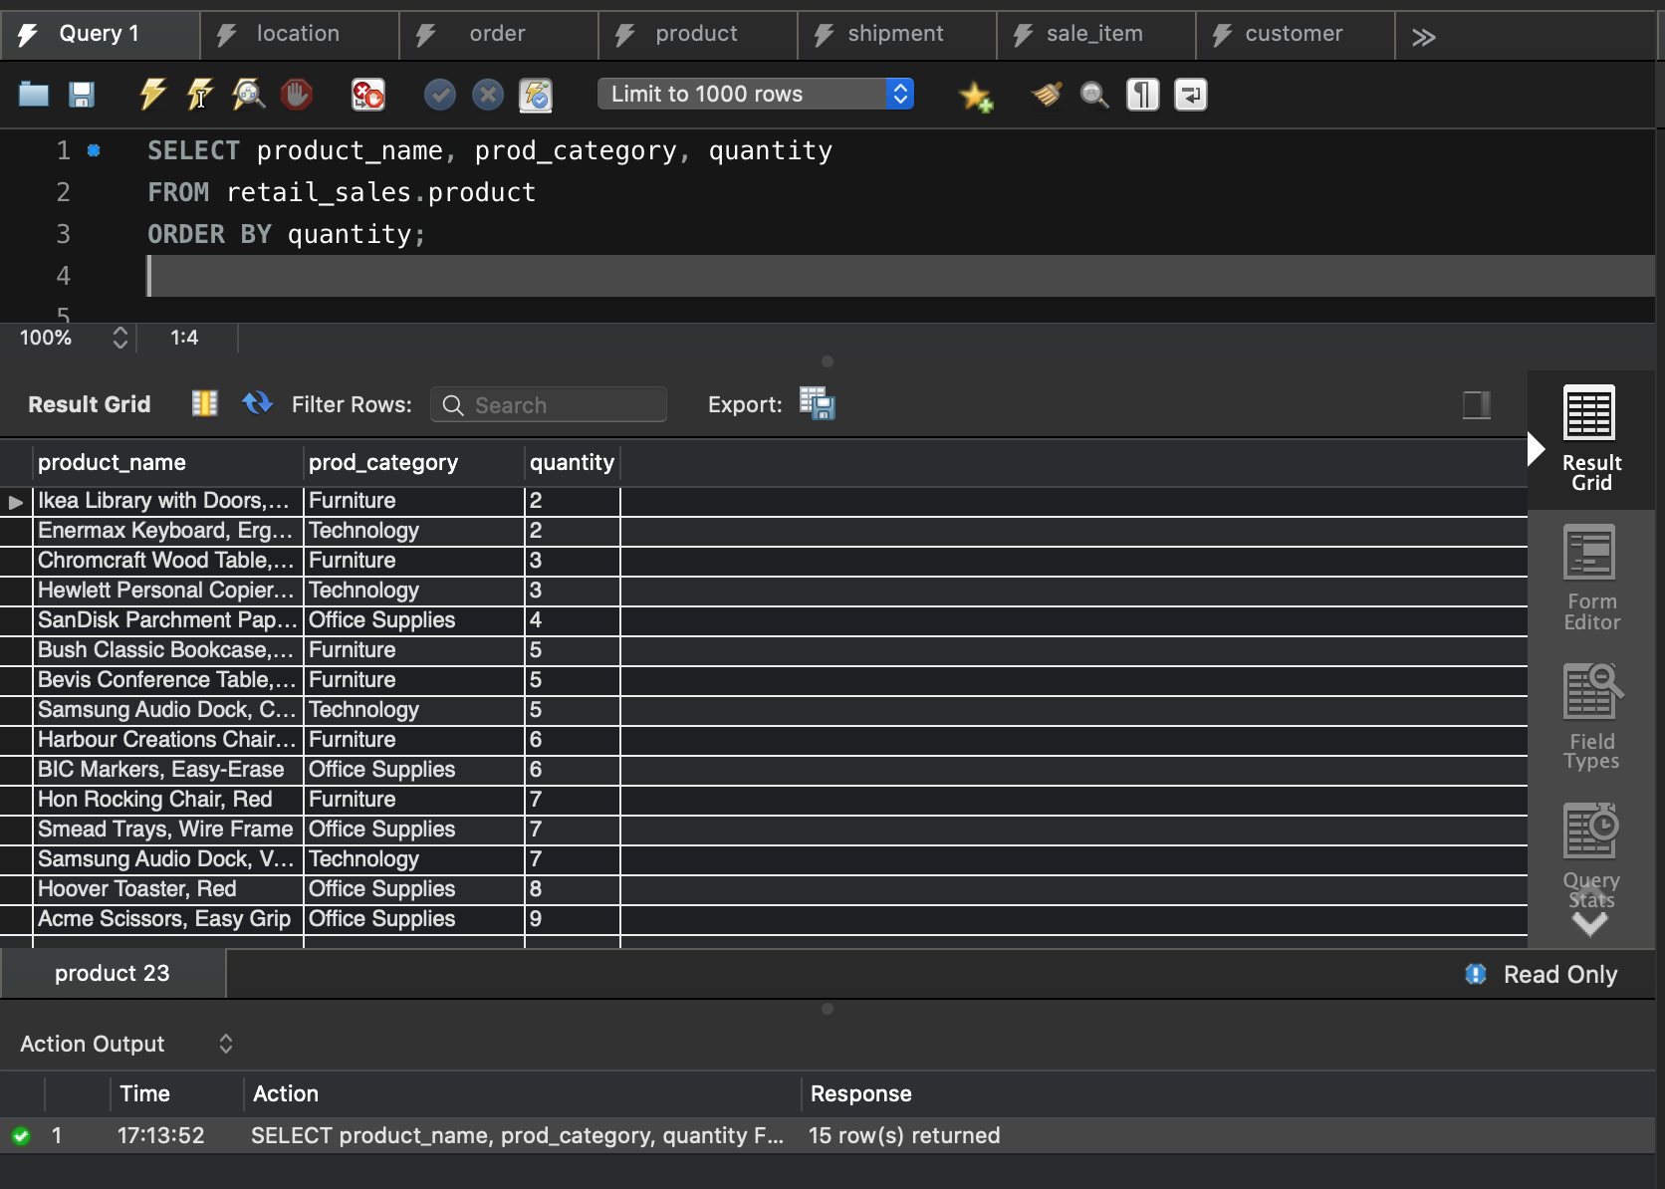

From the above query, we will get the information of number of quantities of the product ordered by the customer. The demand of the product will be known from this query

query – 7 Query that displays the shipping date and order date.

SELECT DISTINCT c.customer_id, c.customer_name, o.order_date, s.shipping_date, o.order_priority

FROM retail_sales.customer c JOIN retail_sales.order o ON c.customer_id = o.customer_id

JOIN retail_sales.shipment s ON c.customer_id = s.customer_id;

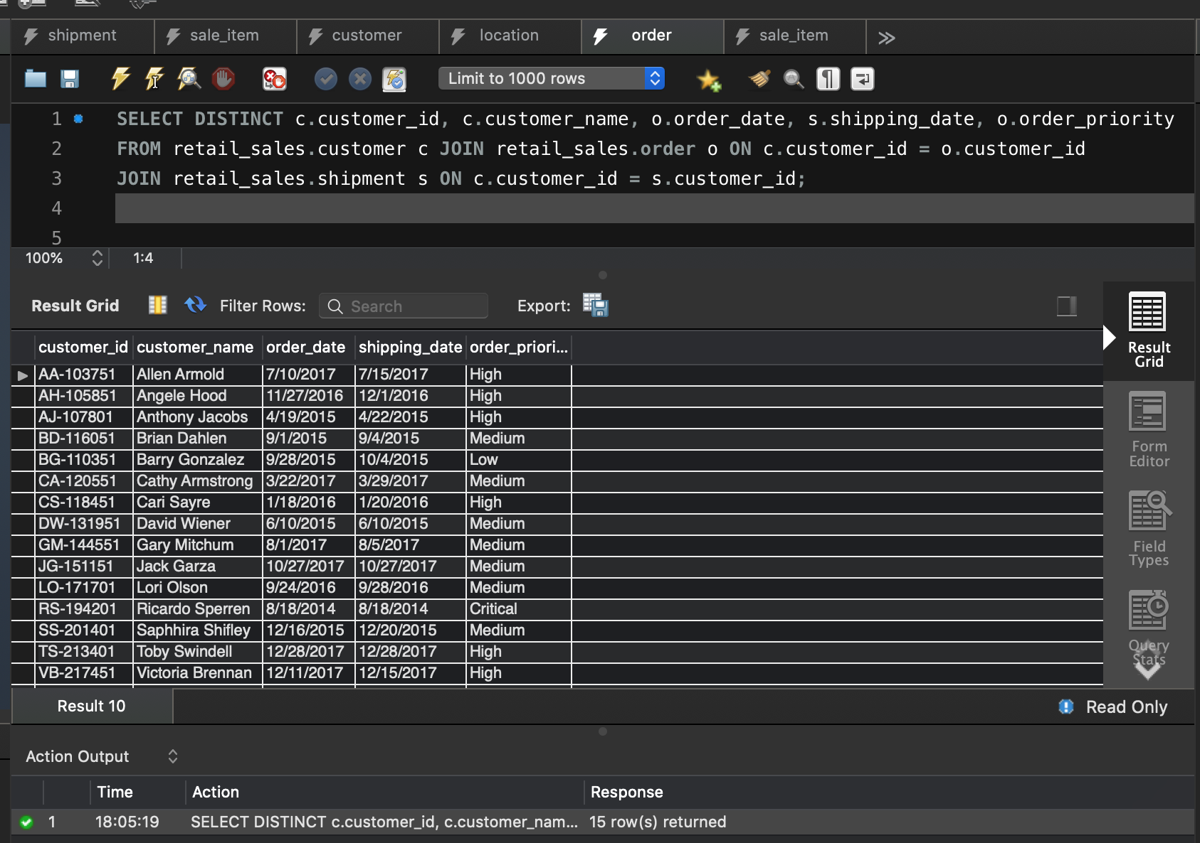

From the above query, we not only get the order date and shipping date. Additionally, we can also know the number of days it took to deliver that product based on the order priority.

Conclusion:

The global retail sales database system is created in a neat manner. It is now easy and effective for the management to take a look of all the customer details, order details and their product details. This helps in forecasting their status and check their progress. Furthermore, it helps to nurture their business and serve the people more efficiently and effectively.

|  |  |  |  |  |  |  |  |
| --- | --- | --- | --- | --- | --- | --- | --- |
|  |  |  |  |  |  |  |  |

|  |  |  |  |  |  |  |  |
| --- | --- | --- | --- | --- | --- | --- | --- |
|  |  |  |  |  |  |  |  |
|  |  |  |  |  |  |  |  |
|  |  |  |  |  |  |  |  |
|  |  |  |  |  |  |  |  |
|  |  |  |  |  |  |  |  |
|  |  |  |  |  |  |  |  |
|  |  |  |  |  |  |  |  |
|  |  |  |  |  |  |  |  |
|  |  |  |  |  |  |  |  |
|  |  |  |  |  |  |  |  |
|  |  |  |  |  |  |  |  |
|  |  |  |  |  |  |  |  |
|  |  |  |  |  |  |  |  |
|  |  |  |  |  |  |  |  |
|  |  |  |  |  |  |  |  |